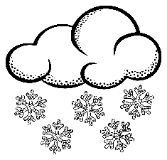  Winter |   Spring
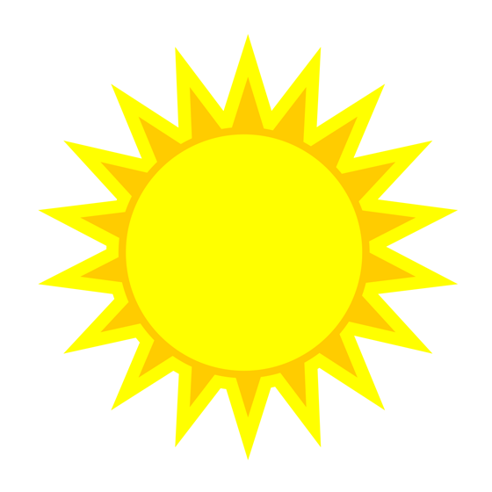  Summer |   Fall
Critical Thinking – Clothes for All Seasons
In each box, draw items of clothing that are appropriate for each season and then write a caption explaining what it is that people usually wear and why.

