Critical Thinking-Wants vs. Needs
 | 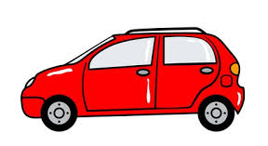 | 
 | 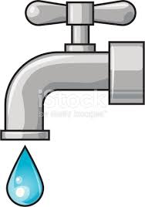 | 
 | 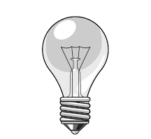 | 


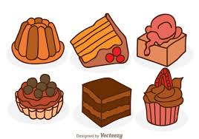

1. What is the difference between a want and a need?
_______________________________________________________________________________________________________________________________________________________________________________________

2. Name three things from the images that are needs. Why?
_______________________________________________________________________________________________________________________________________________________________________________________

3. Name three things from the images that are wants. Why?
_______________________________________________________________________________________________________________________________________________________________________________________

4. Are there any images that are both a want and a need? Explain.
_________________________________________________________________________________________________________________________________________________________________________________________________________________________________________________________________________________________________________________

5. Name 3 more things you want, need and have.

wants needs have
________________ ________________ ________________
________________ ________________ ________________
________________ ________________ ________________

