Basic Computer Skills
Course
will begin
Tuesday, February 14, 2023
and go for 10 weeks.
The course finishes on Thursday, April 27, 2023
Classes are held
twice a week
for two hours, on Tuesdays
and Thursdays.
Morning sessions:
9:45 to 11:45
OR
Afternoon sessions :
2:30 to 4:30

If it is possible for you, we ask for a $25.00 donation. But no one will be refused admission.
Where?
349 Grove Street
Waltham, MA 02453
The Office Building Entrance,
Marist Missionary Sisters
For more information, call us
Tuesdays and Thursdays,
9 – 11:30 AM
at
781 891 5736
Or write us at: maristskillsforlife@gmail.com
Visit us at:
http://maristskillsforlife.org

Improve Your
Computer
Skills
At
Skills for Life

It’s Never
Too Late
Skills For Life
Computer
Training Course
offers courses to residents of Waltham and the surrounding local communities.
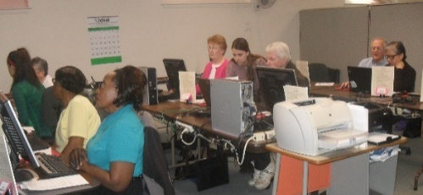
Our goal is to provide adults the opportunity to improve their skills and their job prospects. The program also offers parents and grandparents the opportunity to better understand this technology which affects them, their children and grandchildren.

Our program is very fortunate to have students from Bentley University as volunteer tutors for the students.
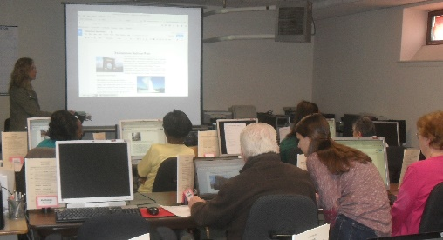
We have had a long
association with Bentley
University, with their
assistance in providing
student volunteers as
tutors as well as with
technical equipment and
assistance.


Basic Computer Skills
Course Content:
Introduction to:
Basic Computer Skills
Internet Access
Email
Using Zoom and Skype
Cloud Services
USB Stick
Applications and files
Digital photos
Internet Security

Requirements:
*Because of the Covid 19
Pandemic, and the fact that
our classroom is located in
a small office building, we
will ask that all participants
be vaccinated against the
virus.
*Be able to climb stairs.
*Classes taught in English.

